**CSE326 PROJECT REPORT**

NAME OF THE PROJECT: **REAL ESTATE**

**DETAILS OF THE PROJECT MEMBERS**

NAME: **PIYUSH**

ENROLLMENT NUMBER: **12012501**

DURATION: **5 days**

DATE OF START: **15/04/2021**

DATE OF END: **25/04/2021**

**-----------------------------------------------------------**

**DETAILS OF THE PROJECT MEMBERS**

NAME: SUMANT KUMAR

ENROLLMENT NUMBER: 12012575

**DURATION: 8 Days**

**DATE OF START: 12/04/2021**

**DATE OF END: 20/04/2020**

**------------------------------------------------------------**

**DETAILS OF THE PROJECT MEMBERS**

NAME: UJJWAL PRAKASH

ENROLLMENT NUMBER:

**DURATION:**

**DATE OF START:**

**DATE OF END:**

**---------------------------------------------------------------**

**Aim of the Project -** To make a Real Estate website with the help of HTML, CSS and JAVASCRIPT. The website should contain some pages like About, Contact, Buy, Sell, Login and Gallery.

**About the Project: -** This project is made with the help of **HTML, CSS** and **JavaScript.** We named the website as **REAL ESTATE KINGS,** where you can buy and sell your property from any part of the world online.

The **Homepage/Landing Page** **realestetekings.com** contains various awesome features like you **can search for your desired properties** and the **list of some featured Properties**. You also a **bunch of properties searches** which people search on our site. We also provide some of the counts like **Total number of people Visited on the Site** and **How many Properties listed** on our website till date.

For making the website safe and secure we have an option of **User Login** through which any user can login to our website and if he is new to our website then on clicking on the **Register** button he can signup for our website and then proceed to selling and buying options.

In this website you get the feature of both **selling** and **buying** the properties from all over the world. You can ask request the seller/Agent of the property for more pictures of the property you are interested in and you can also contact them through their contact number and email address. If you are a seller and want to sell your property then you can add details of your property, add pictures of it, and location and can post for selling process.

You also get a **Blog** section in which you can read blogs related property registration, top property sold and many more.

Most important, if you feel like there is something wrong in the site or any problem related to services provided by REAL ESTATE KINGS then you can **contact us** easily by filling a form in which you get options like Name, Mobile Number and Email Id and then write your Query.

You get the google map embedded on the site if you want to Find Us, our location or Main office.

**CONTRIBUTION MEMBER WISE**

|  |  |  |
| --- | --- | --- |
| Member details | Page1 | Page2 |
| Sumant Kumar | HOMEPAGE, LOGIN PAGE  HTML, CSS, JS | Buy-Property-View, About Us  HTML,CSS, JS |
| Piyush | BUY-PROPERTY,  SELL-PROPERTY  HTML, CSS, JS | CONTACT US, GALLERY  HTML, CSS, JS |
| Ujjwal Prakash | Page title and details of the features of the web page.  Details of the technology you have used. | Page title and details of the features of the web page.  Details of the technology you have used. |

**SNAPSHOTS**

**Homepage:** 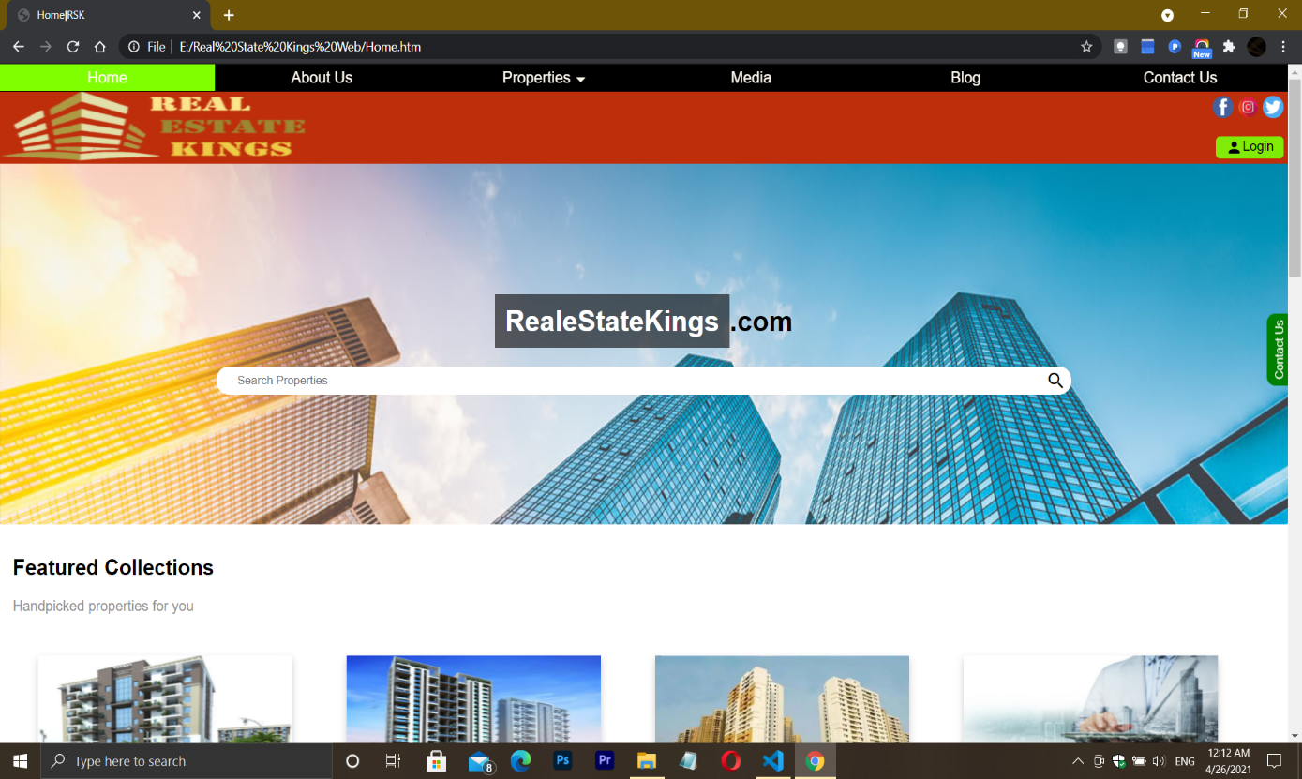

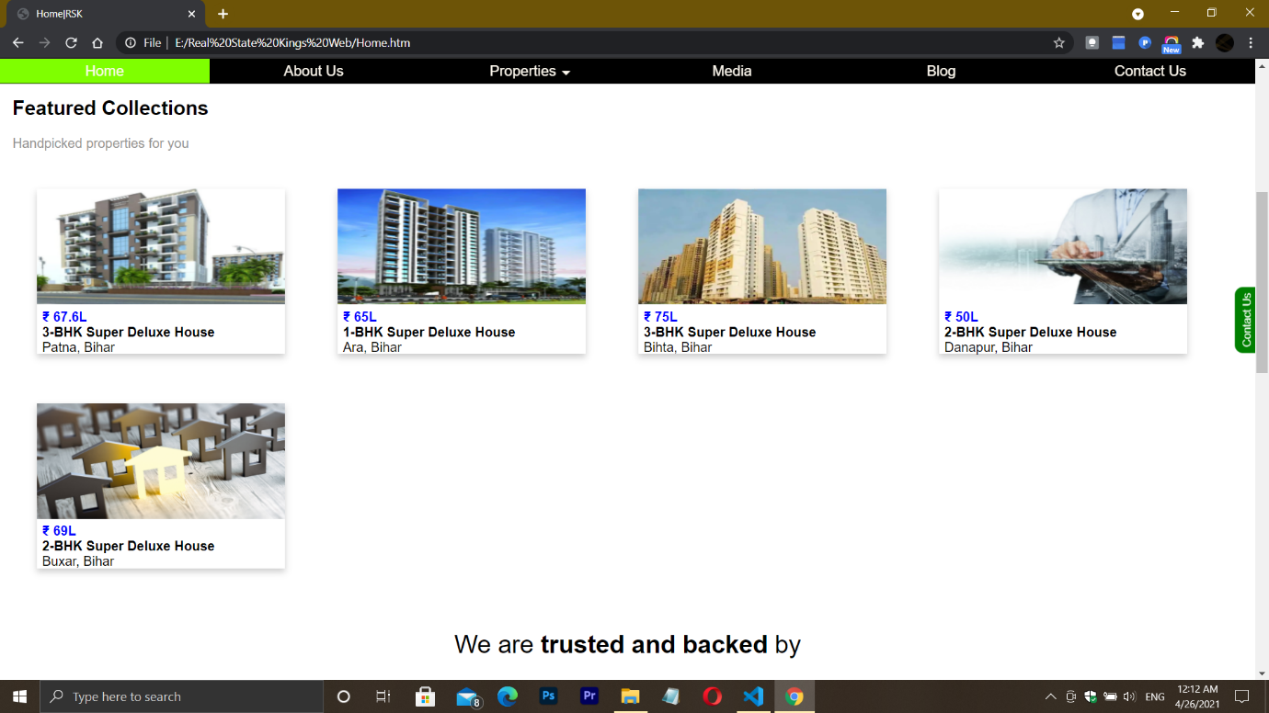

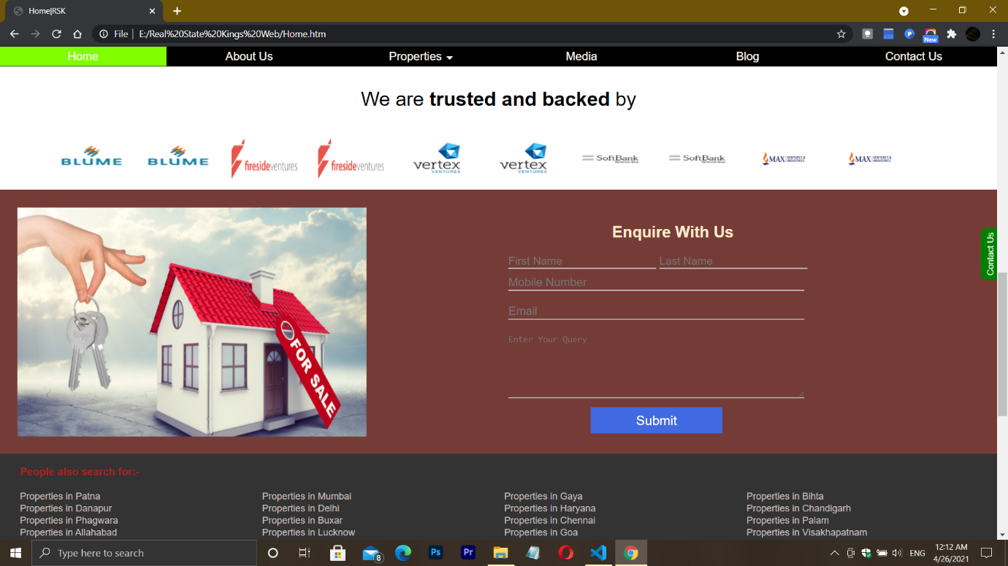

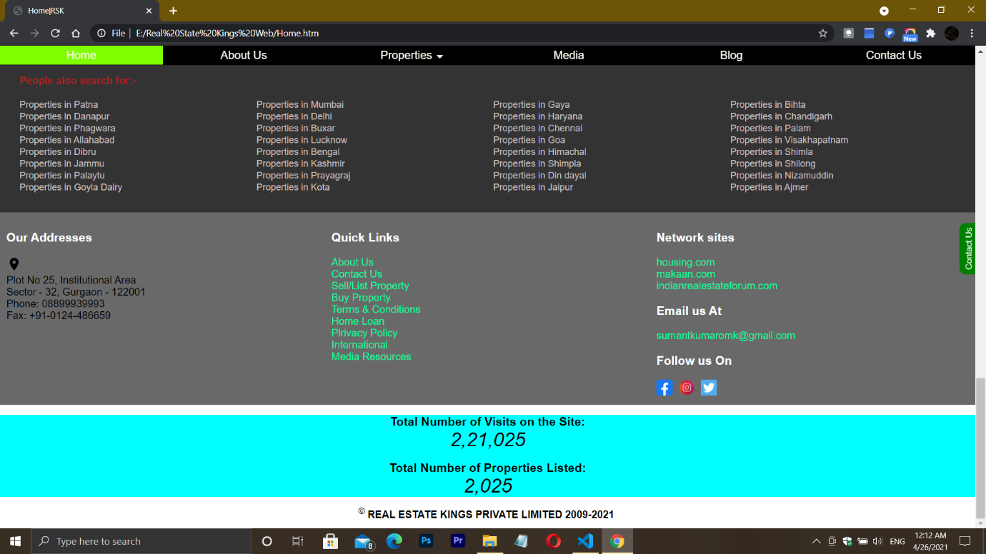

**Login:**

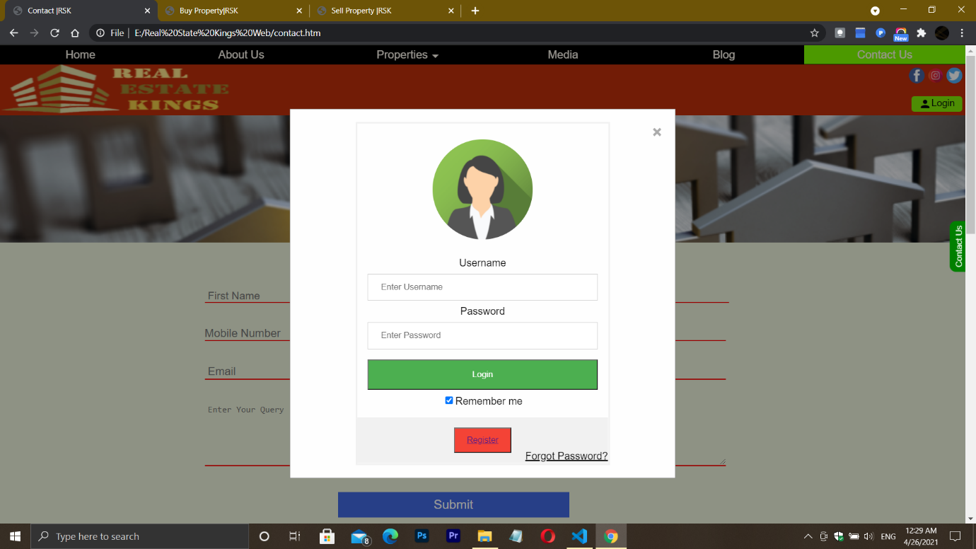

**About Us:**

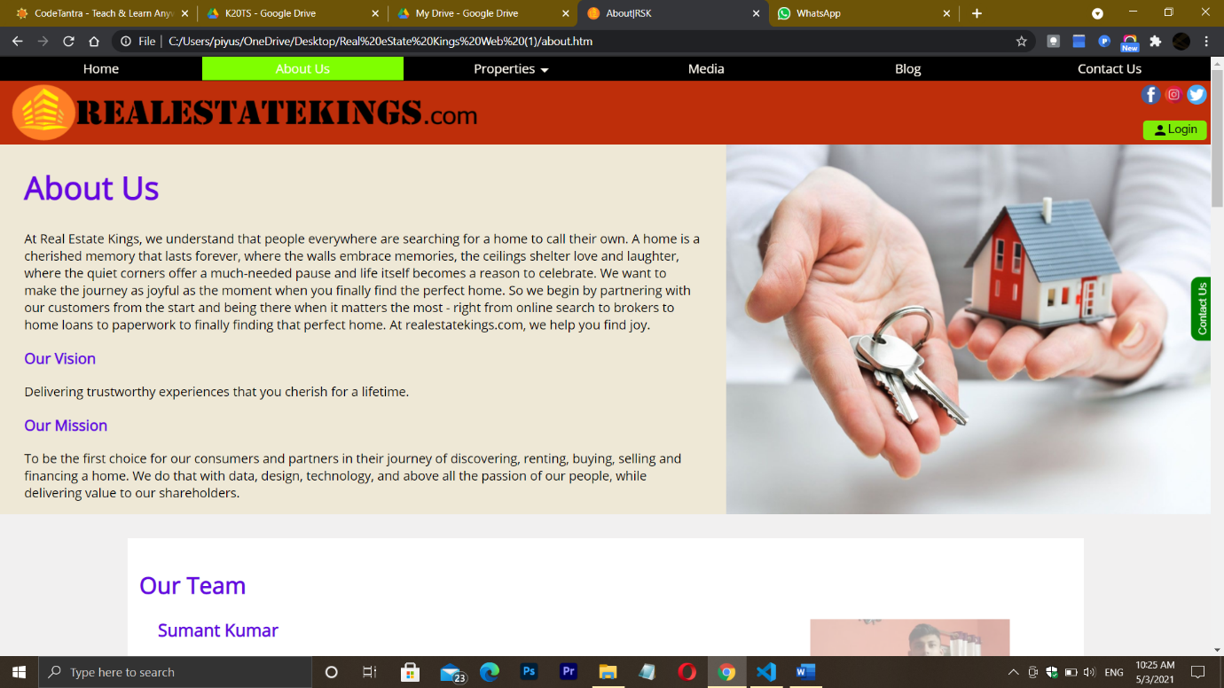

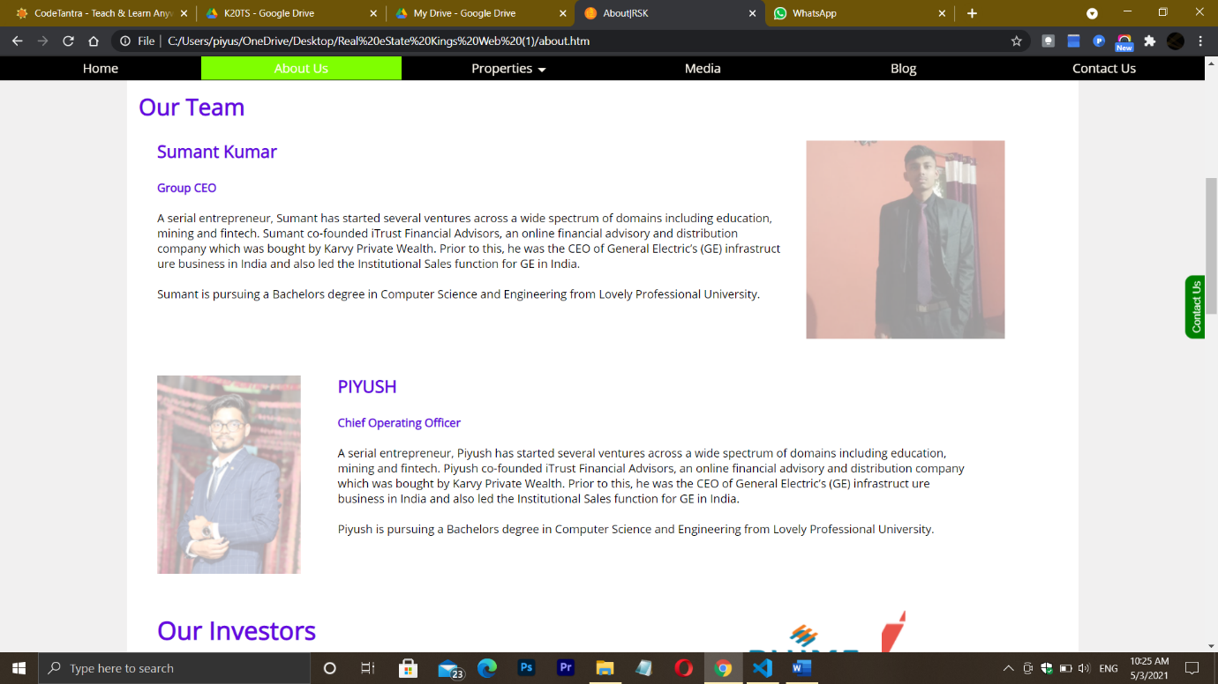

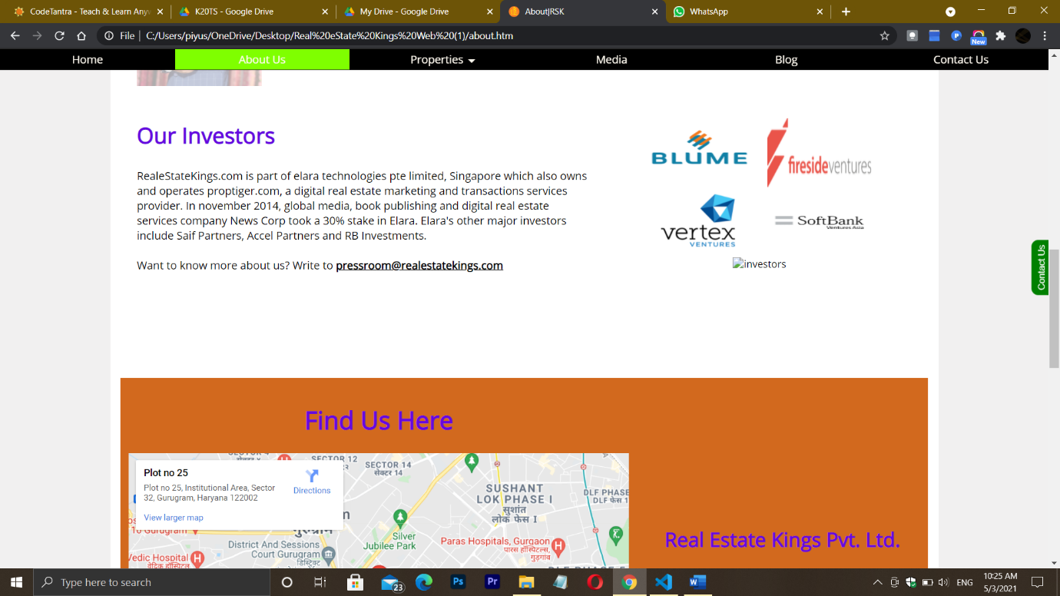

**Properties:**

1. **i) Buy Properties:**

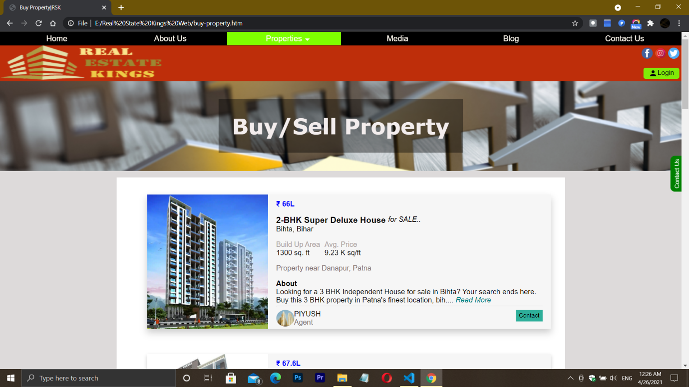

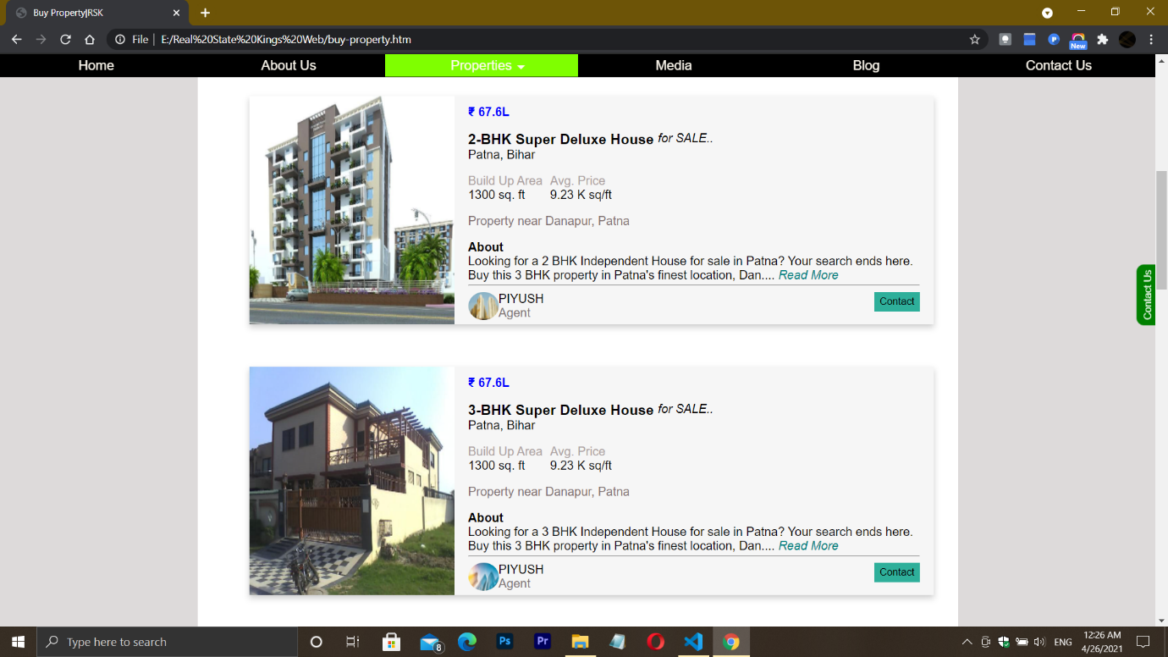

**ii) View Properties:**

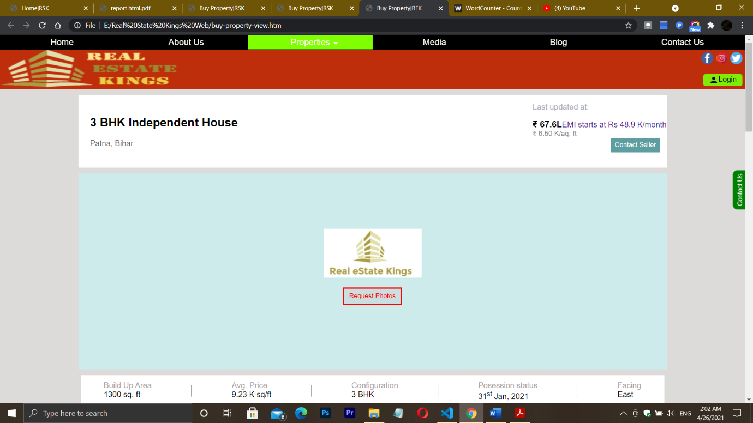

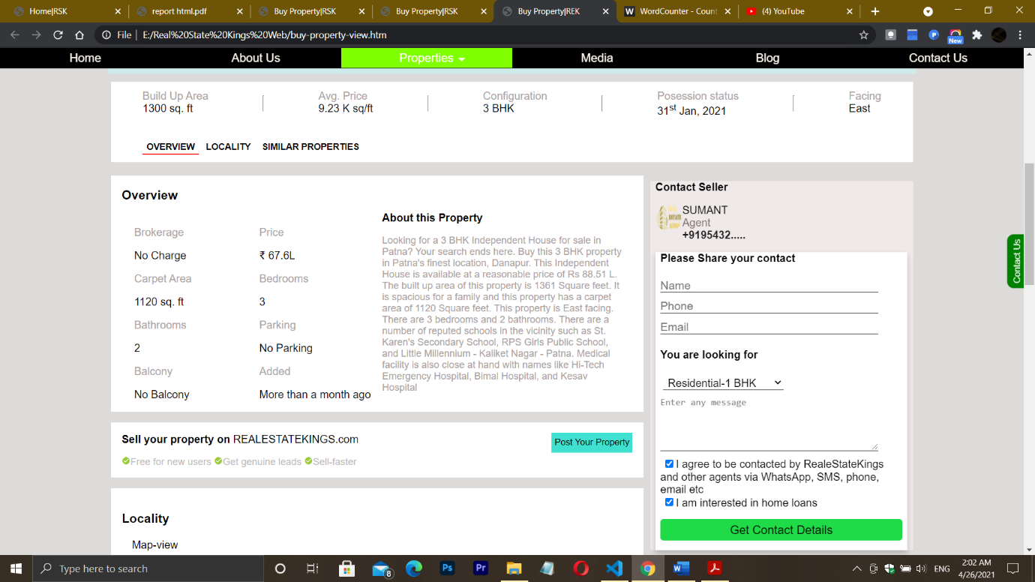

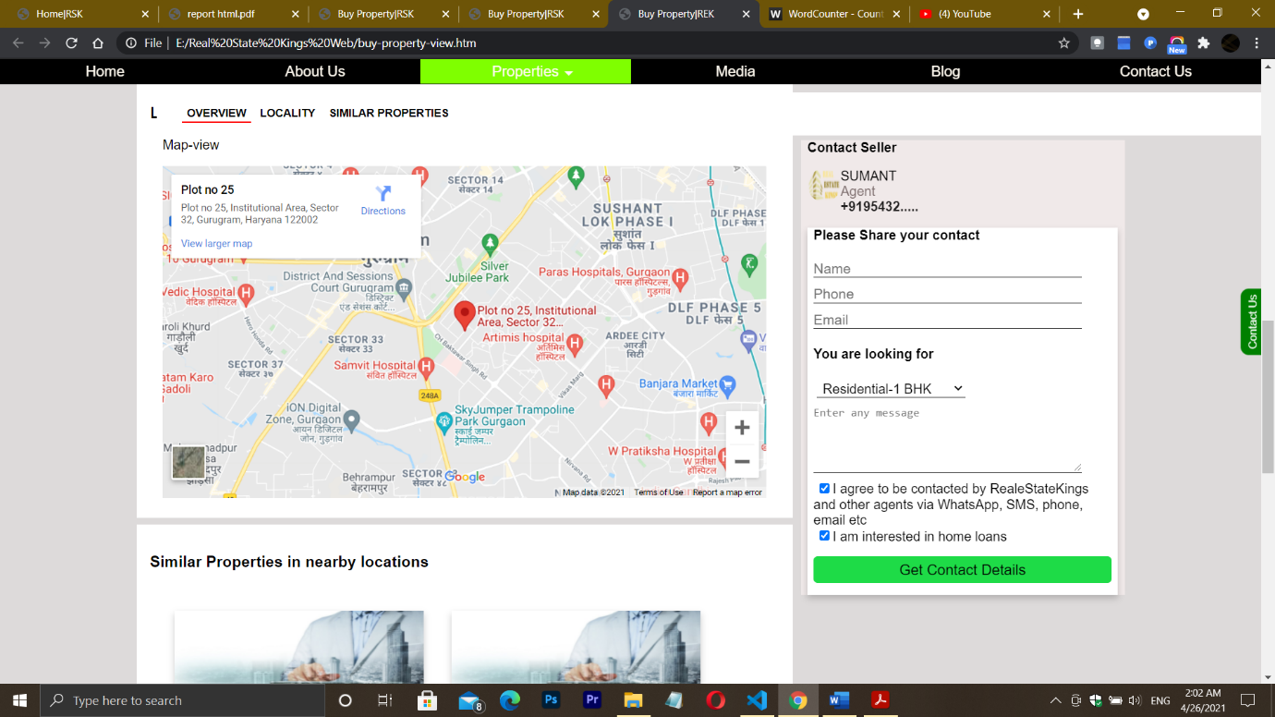

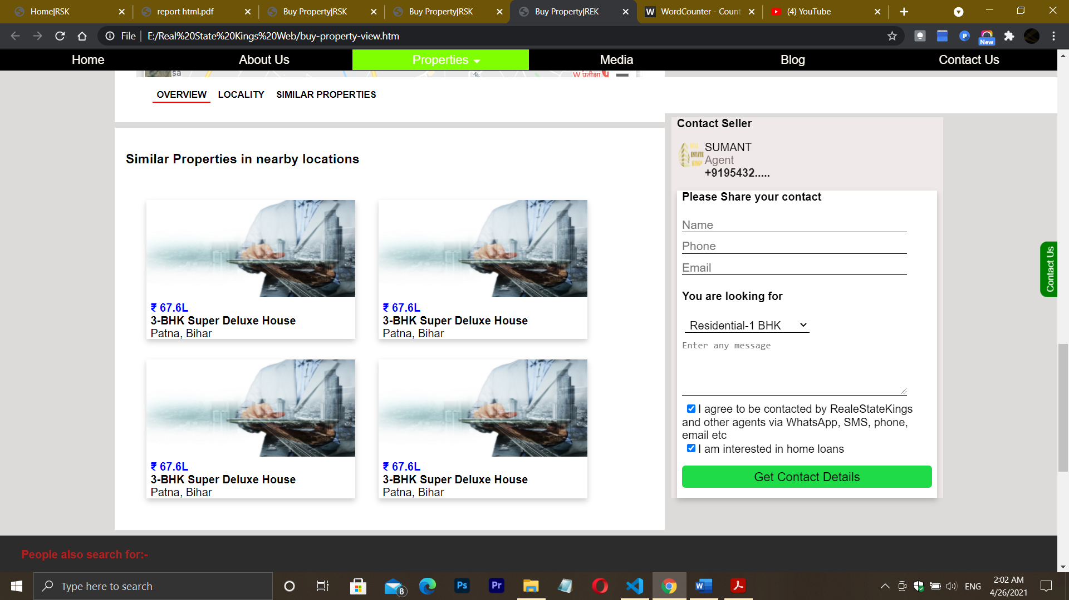

1. **Sell Properties:**

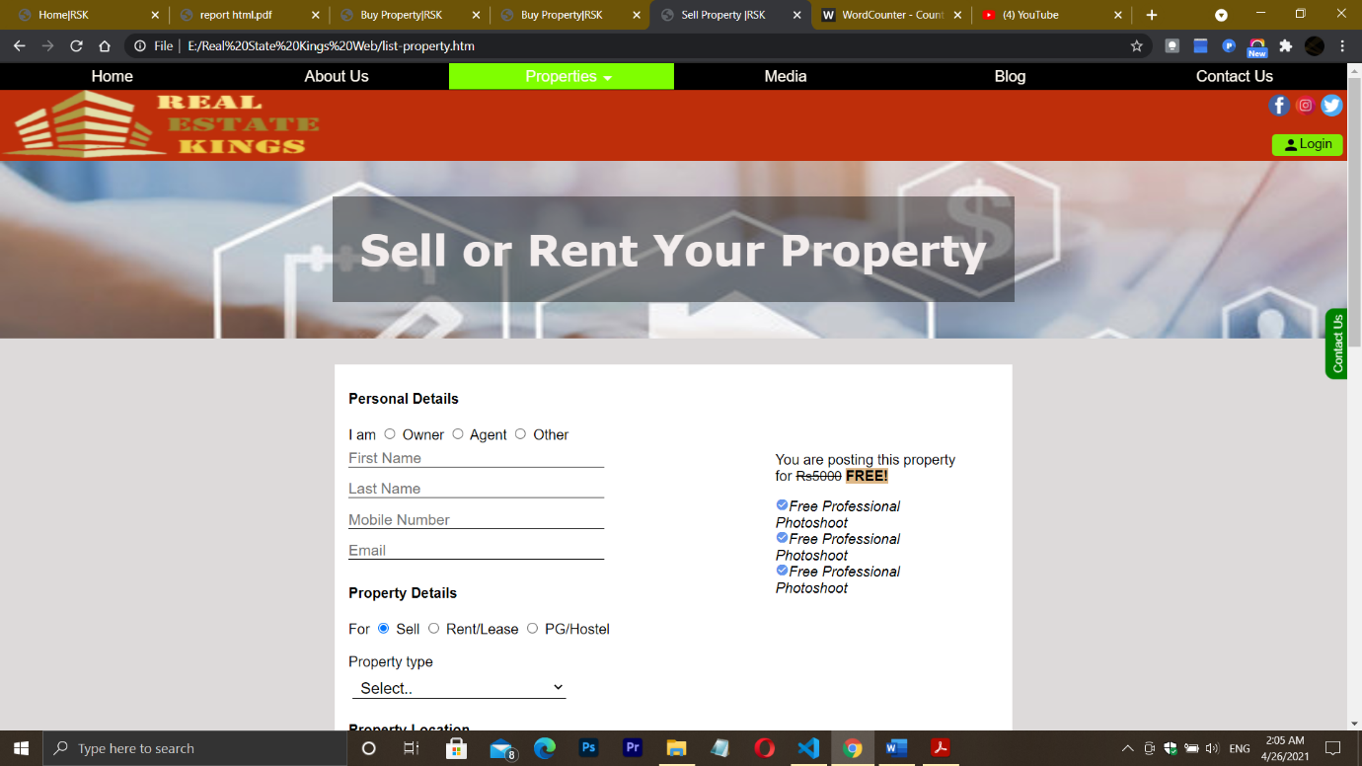

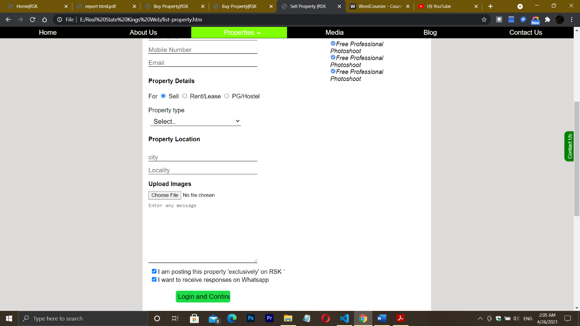

**Media:**

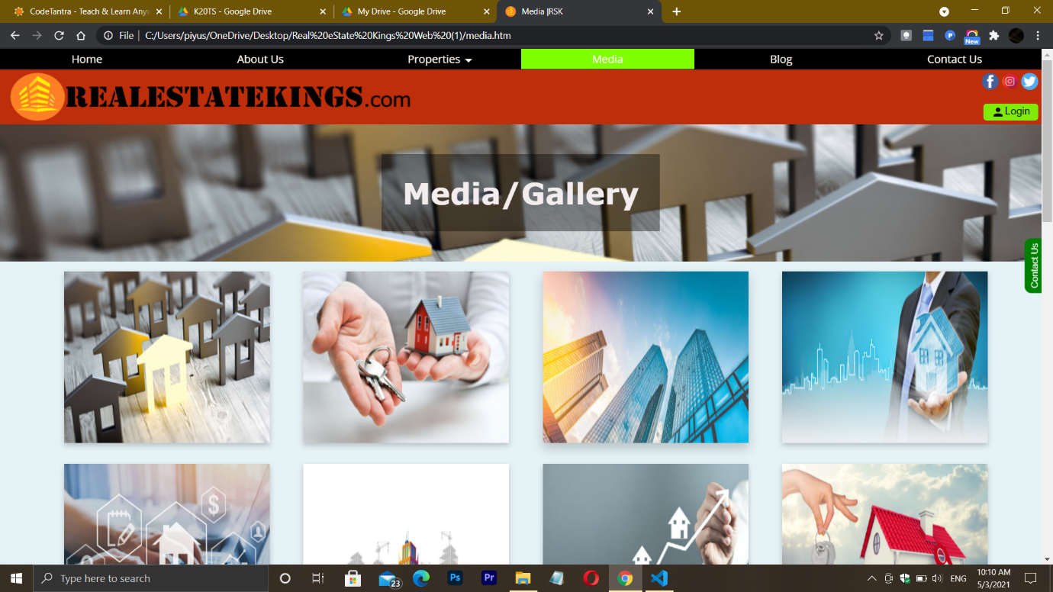

**Blog:**

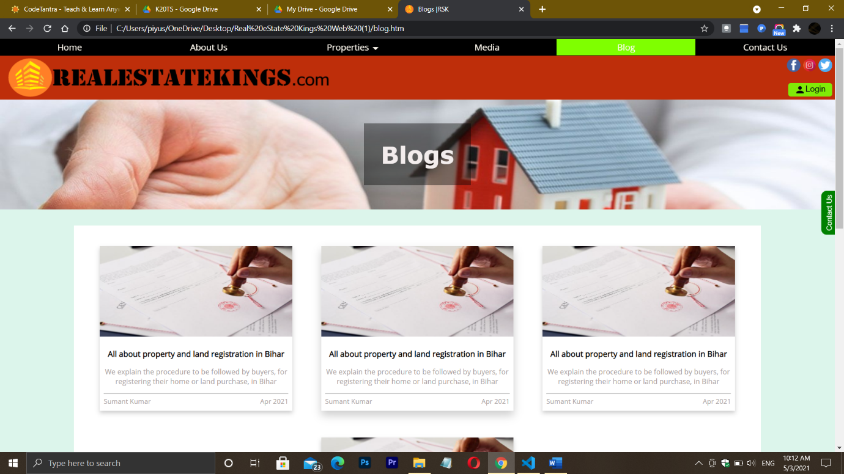

**Contact Us:**

